Chapter 10, Solution 68.

For the circuit in Fig. 10.111, obtain the Thèvenin equivalent at terminals a-b.

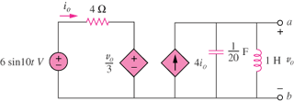

Figure 10.111
For Prob. 10.68.

Solution
We obtain V_{Th} using the circuit below.

I_{o} 4
a

+ +

+ -j2 j10 V_{o}
6<0º V_{o}/3 - 4I_{o}
- -
b

(1)
(2)

Combining (1) and (2) gives

To find R_{Th,} we insert a 1-A source at terminals a-b, as shown below.

I_{o} 4
a

+

+ -j2 j10 V_{o}
V_{o}/3 - 4I_{o}
1<0º
-

Combining the two equations leads to

